# Login Use Case Diagram

## Section 1: The Primary Presentation

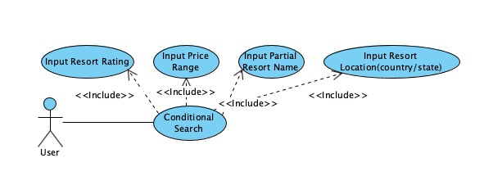

## Section 2: The Element Catalog

### 2.1 Elements and their properties

The stick-figure element represents an actor, from which the use case is initiated. Each oval represents a use case, which is a specific situation for which the product can be used. Lastly, there is the database element, which participates in the action by providing data back.

### 2.2 Relations and their properties

Solid lines represent associations, by which the elements are joined. The segmented lines represent the inclusion of separate use cases, within others.

## Section 3: Context Diagram

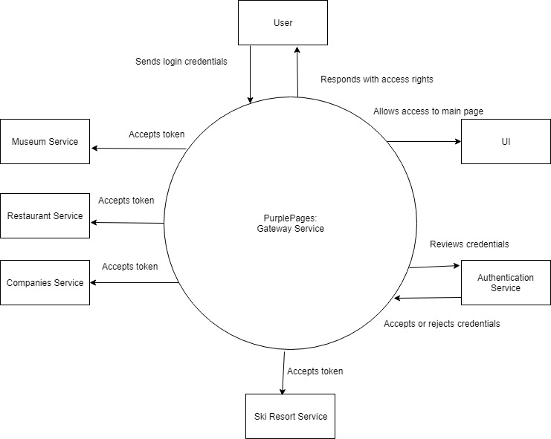

## Section 4: Variability Guide

There are no variation points for this diagram.

## Section 5: Rationale

This diagram illustrates a standard ski resort search procedure. Users are required to input searching conditions, including partial resort name, country name, province name, resort ratings as well as price range. At least one of the mentioned conditions should be provided by the user.